AI ASSISSTED CODING-10:
HALL NO:2403A52141
BATCH NO:06

TASK-1:
Identify and fix syntax, indentation, and variable errors in the given script.
# buggy_code_task1.py
def add_numbers(a, b)
result = a + b
return reslt
print(add_numbers(10 20))

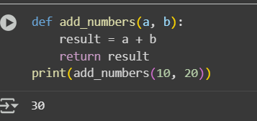

ERROR:
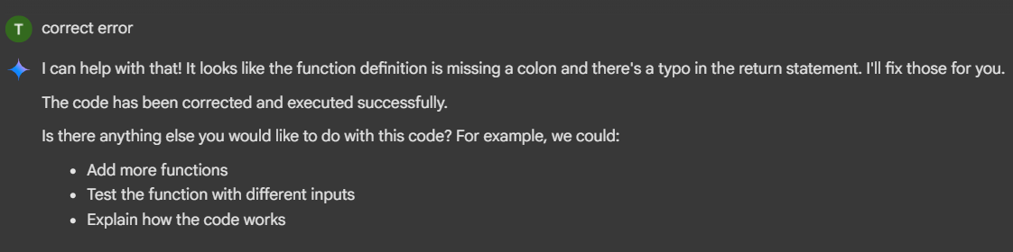

EXPLANATION:
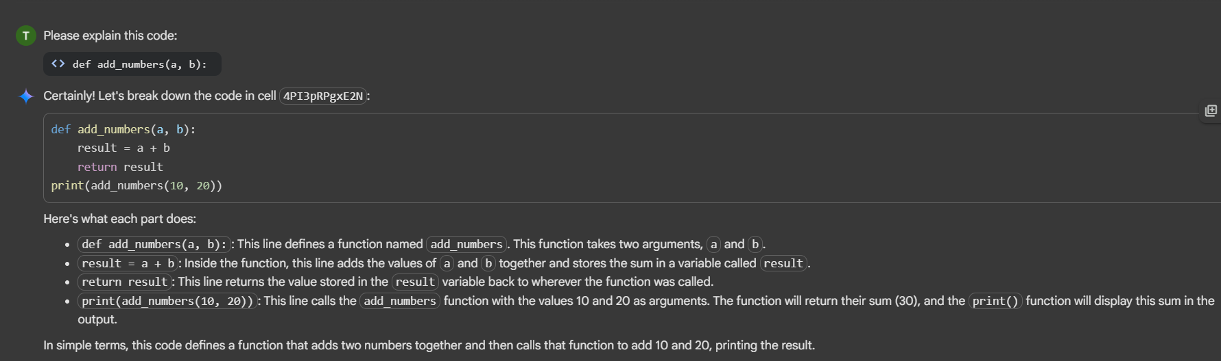
TASK-2:
: Optimize inefficient logic while keeping the result correct.
# buggy_code_task2.py
def find_duplicates(nums):
duplicates = []
for i in range(len(nums)):
for j in range(len(nums)):
if i != j and nums[i] == nums[j] and nums[i] not in duplicates:
duplicates.append(nums[i])
return duplicates
numbers = [1,2,3,2,4,5,1,6,1,2]
print(find_duplicates(numbers))
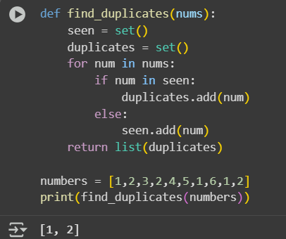

EXPLANATION:
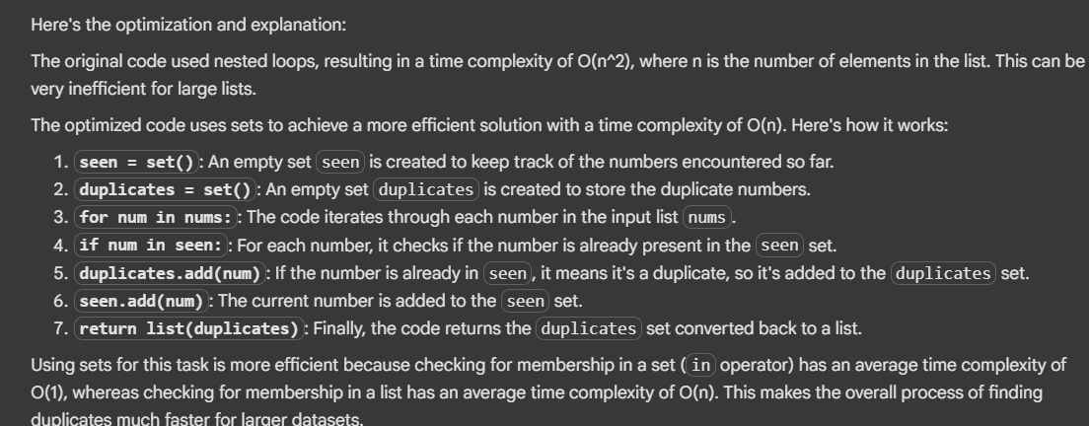

TASK-3:
Refactor messy code into clean, PEP 8–compliant, well-structured code.
# buggy_code_task3.py
def c(n):
x=1
for i in range(1,n+1):
x=x*i
return x
print(c(5))

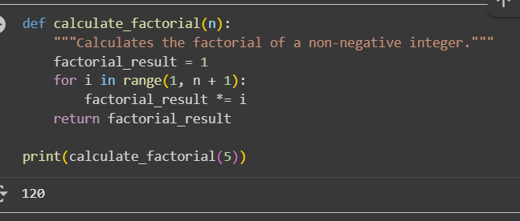
EXPLANATION:
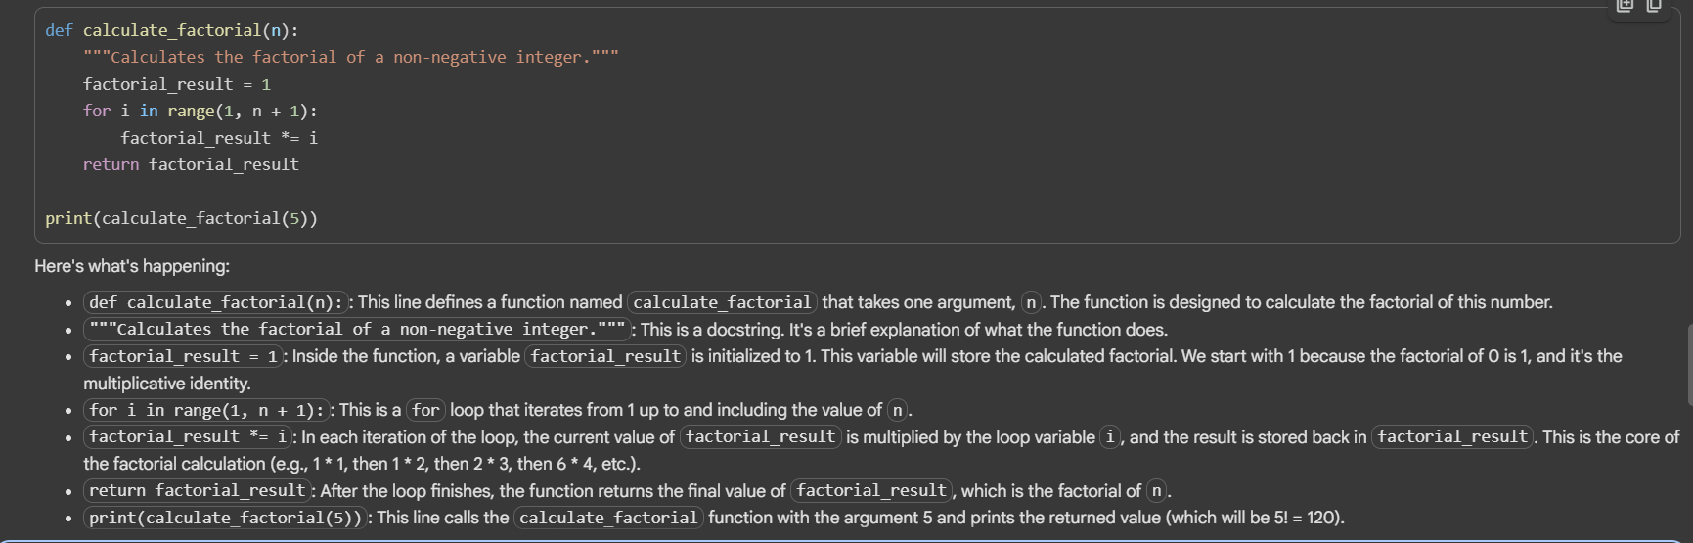

TASK-4:
: Add security practices and exception handling to the code.
# buggy_code_task4.py
import sqlite3
def get_user_data(user_id):
conn = sqlite3.connect("users.db")
cursor = conn.cursor()
query = f"SELECT * FROM users WHERE id = {user_id};" # Potential SQL injection risk
cursor.execute(query)
result = cursor.fetchall()
conn.close()
return result
user_input = input("Enter user ID: ")
print(get_user_data(user_input))

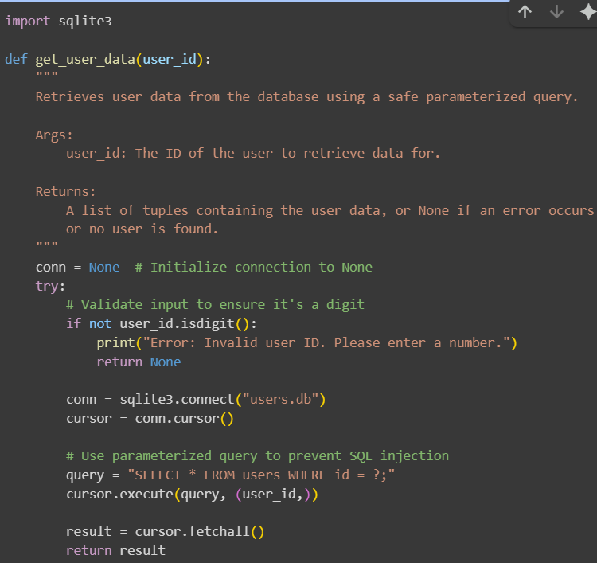
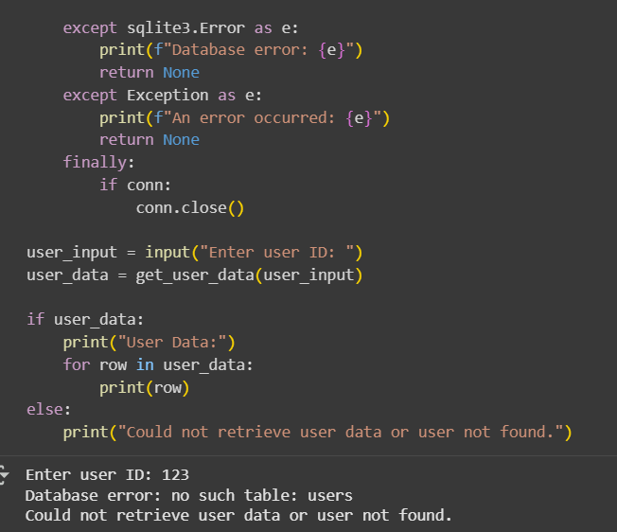

EXPLANATION:
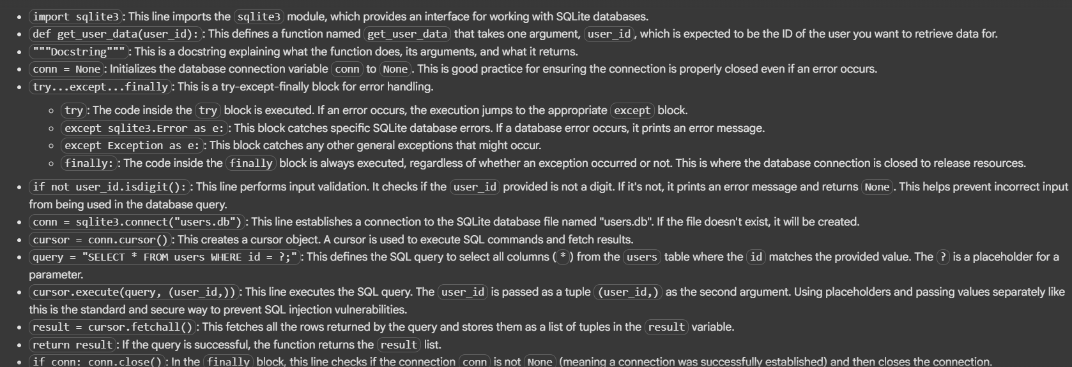

TASK-5:
Generate a review report for this messy code.
# buggy_code_task5.py

def calc(x,y,z):
if z=="add":
return x+y
elif z=="sub": return x-y
elif z=="mul":
return x*y
elif z=="div":
return x/y
else: print("wrong")
print(calc(10,5,"add"))
print(calc(10,0,"div"))

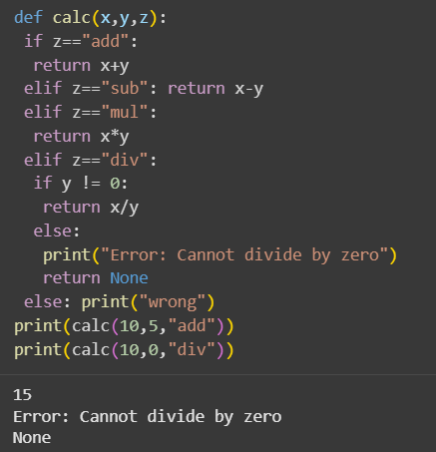

EXPLANATION:
